1.Total Customers
select count(*)as total_customer
from loan_prediction;


2.Risk Distribution
select risk_flag, count(*) as total_customer
from loan_prediction
group by risk_flag;
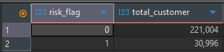

3.Risk percentage
select risk_flag,
count(*) as total_customer,
round(
(count(*) *100.0) / (select count(*)from loan_prediction), 2) as percentage
from loan_prediction
group by risk_flag;
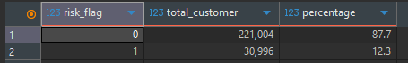

4. Top Risky Profession
select profession,
count(*)as total_customer,
avg(risk_flag)as risk_rate
from loan_prediction
group by profession
order by risk_rate desc
limit 10;

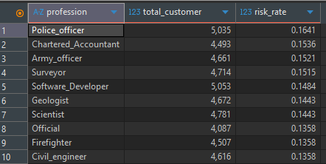

5. State wise Risk
select state,
count(*) as total_customer,
avg(risk_flag) as risk_rate
from loan_prediction
group by state
order by risk_rate desc
limit 10;
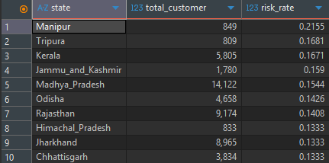

6. Experienced level analysis
select
case
when experience < 2 then 'Fresher'
when experience between 2 and 5 then 'Mid'
else 'Experienced'
end as exp_level,
avg(risk_flag) as risk_rate
from loan_prediction
group by exp_level;
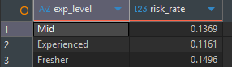

7. Rank states by risk
select state,
Avg(risk_flag) as risk_rate,
rank() over(order by avg(risk_flag) desc ) as rank_position
from loan_prediction
group by state
limit 10;

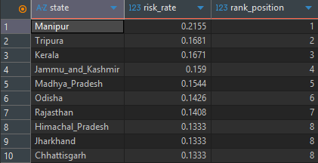

8. Top 5 Highest income customers
select *
from loan_prediction
order by income desc
limit 5;
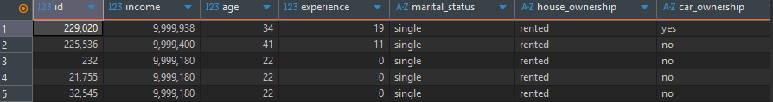
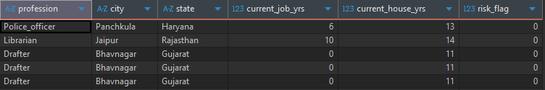

9. Customers above average income
select *
from loan_prediction
where income>(select avg(income) from
loan_prediction)
limit 10;
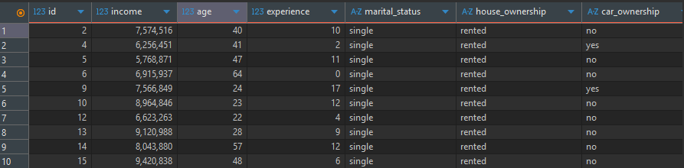

10. Risk by Marital Status
select marital_status,
count(*) as total_customer,
avg(risk_flag) as risk_rate
from loan_prediction
group by marital_status;
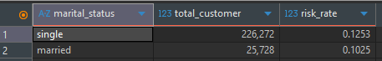\
11.Combine Multiple Conditions
select *
from loan_prediction
where income<300000
and experience<2
and risk_flag=1
limit 10;
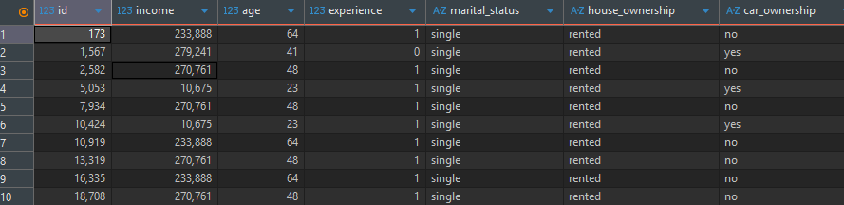
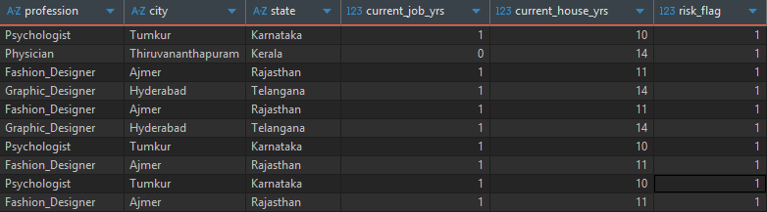

12.Income Group Analysis
select
case
when income<300000 then 'Low'
when income between 300000 and 700000 then 'Medium'
else 'High'
end as Income_group,
count(*) as total_customers,
avg(risk_flag) as risk_rate
from loan_prediction
group by income_group;
